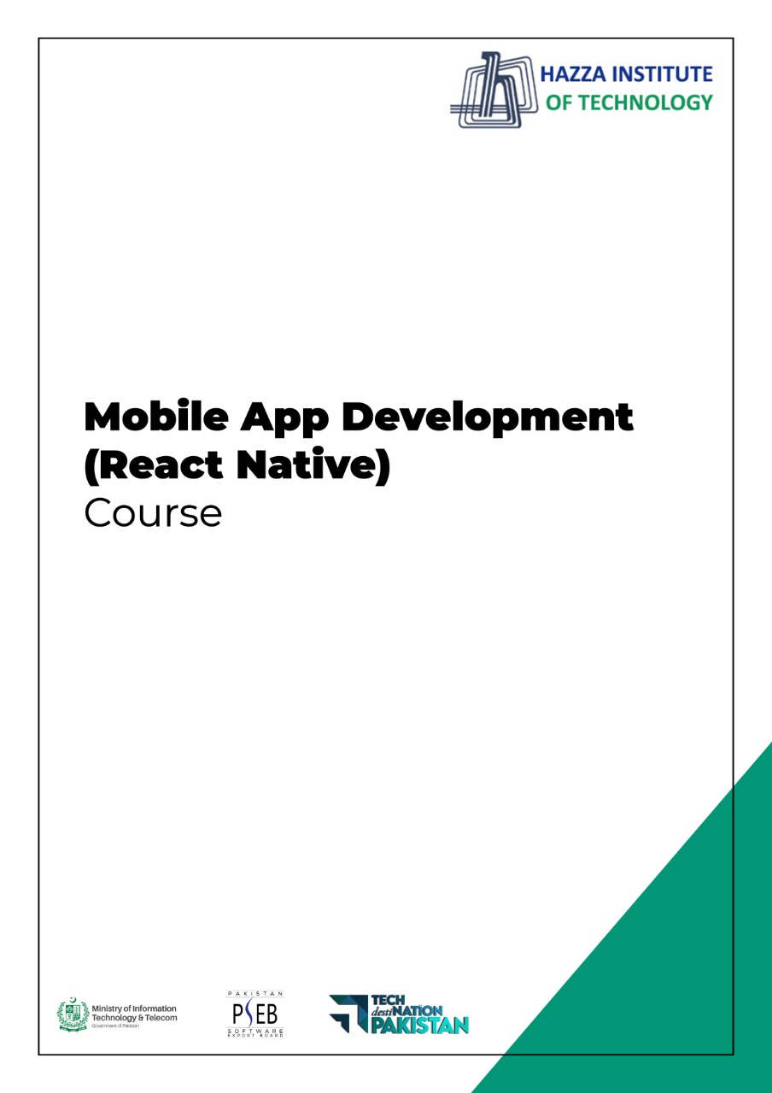

**(React Native)**

Term 1 Paper

**TERM 1 PAPER**

Total Marks; 100

Q1: What is Flexbox and describe any elaborate on its most used properties? (20 Marks)

Q2: What is the relationship between React Native and React? (20 Marks)

Q3: Why do we use StyleSheet.create? What are the tradeoffs with this approach? (20 Marks)

Q4: What is Prop drilling in React? (20 Marks)

Q5: Is ReactJS same as React Native? (20 Marks)